

**DIPLOMA IN DIGITAL ADVERTISING DESIGN (DSK)**

DAC 30124

INNOVATION PROJECT MANAGEMENT

SEMESTER 3A

SESSION JULAI – DECEMBER 2025

CASE STUDY ON A SENIOR CITIZEN INNOVATION

**AHLI KUMPULAN**

**NAMA : Arriana binti Basarudin**

**NO. MATRIKULASI :** 333421255318

**NO. KAD PENGENALAN:** 060529 - 07 - 0186

**NO. TELEFON :** 011-55099144

**E-MEL :** arriana@sgpetani.ikm.edu.my

**NAMA : Izyani binti Maliki**

**NO. MATRIKULASI :** 333421255415

**NO. KAD PENGENALAN:** 061216 - 02 - 0510

**NO. TELEFON :** 011-55812394

**E-MEL :** izyani@sgpetani.ikm.edu.my

**NAMA : Nur aina bt zulkifli**

**NO. MATRIKULASI :** 333421255224

**NO. KAD PENGENALAN:** 060209 - 02 - 0200

**NO. TELEFON :** 011-37172318

**E-MEL :** nuraina@sgpetani.ikm.edu.my

**ISI KANDUNGAN**

|  |  |  |
| --- | --- | --- |
|  | Acknowlegment | 4 |
| 2. | Introduction About Innovation  2.1 Article | 5  6 |
| 3. | Introduction  3.1 Project Overview  3.2 Background  3.3 Problem Statement |  |
| 4. | Objectives and Purpose Of The Case Study  4.1 Objectives  4.2 Purpose |  |
| 5. | Literature Review  5.1 Related Literature  5.2 Theories and Concepts |  |
| 6. | Research Methodology  6.1 Research Methods  6.2 Study Sample  6.3 Research Instruments |  |
| 7. | Project Overview  7.1 Project Design  7.2 Implementation Process  7.3 Risk Management Plan |  |

|  |  |  |
| --- | --- | --- |
| 8. | Data Analysis and Findings  8.1 Data Analysis  8.2 Key Analysis  8.3 Impact On The Community |  |
| 9. | Public Opinion  9.1 Feedback  9.2 Strengths and Weaknesses |  |
| 10. | Conclusions and Recommendations  10.1 Summary of Findings  10.2 Future Recommendations  10.3 Policy Implications |  |
| 11. | References |  |

1. **ACKNOWLEDGEMENT**

We would like to express our deepest appreciation to our innovation lecturer, Mr. Muhammad Fauzi Bin Harun, for his invaluable guidance, encouragement, and continuous support throughout the duration of this project. From the very beginning of the grouping process until the completion of our work, he has been a constant source of knowledge, motivation, and constructive feedback. His insightful advice has enabled us to form effective teamwork, enhance our collaboration, and build confidence in presenting our innovative ideas.

Mr. Muhammad Fauzi Bin Harun’s dedication and commitment to mentoring us have played a vital role in shaping not only the progress of our project but also our personal growth as students. Through his guidance, we learned to appreciate the importance of teamwork, effective communication, and respect for different perspectives. He has inspired us to share ideas openly, solve challenges creatively, and strive for excellence in every stage of this innovation project.

We are truly grateful for his patience in addressing our questions, his encouragement in moments of difficulty, and his ability to push us beyond our comfort zone to achieve more than we initially thought possible. The knowledge, values, and experience gained under his supervision will remain meaningful to us and will continue to guide us in future endeavors.

Without his support and guidance, this project would not have been accomplished successfully. Therefore, we wholeheartedly extend our utmost gratitude and respect to Mr. Muhammad Fauzi bin Harun for his dedication, wisdom, and unwavering commitment in guiding us throughout this innovation journey.

Thank you all.

1. **INTRODUCTION ABOUT INNOVATION**

Innovation is the process of creating, developing, and applying new ideas, methods, products, or services that provide unique improvements and meaningful value to individuals, organizations, and society. It goes beyond invention, which is simply the act of creating something new, by focusing on the practical implementation and adoption of ideas. Innovation transforms creative concepts into real solutions that address challenges, improve quality of life, and generate positive change.

In today’s fast-changing world, innovation can take many forms: technological such as digital applications, smart devices, and medical tools, social such as new systems of community support, and business-related such as improved customer services and delivery systems. What makes innovation powerful is its ability to solve real-world problems while being adaptable and sustainable.

One important aspect of innovation is its role in protecting and supporting vulnerable groups, including senior citizens. As the elderly population grows, they face challenges such as declining vision, reduced mobility, and limited access to information. Innovation can directly address these needs through tools like easy-to-read digital applications, healthcare technologies, or accessible community platforms. These solutions not only make life more convenient for older adults but also safeguard their well-being, dignity, and independence.

In this sense, innovation is not just about advancement or efficiency it is also about caring for people and ensuring inclusivity. By designing innovative solutions that protect senior citizens, society moves toward a more compassionate, resilient, and sustainable future.

**Article**

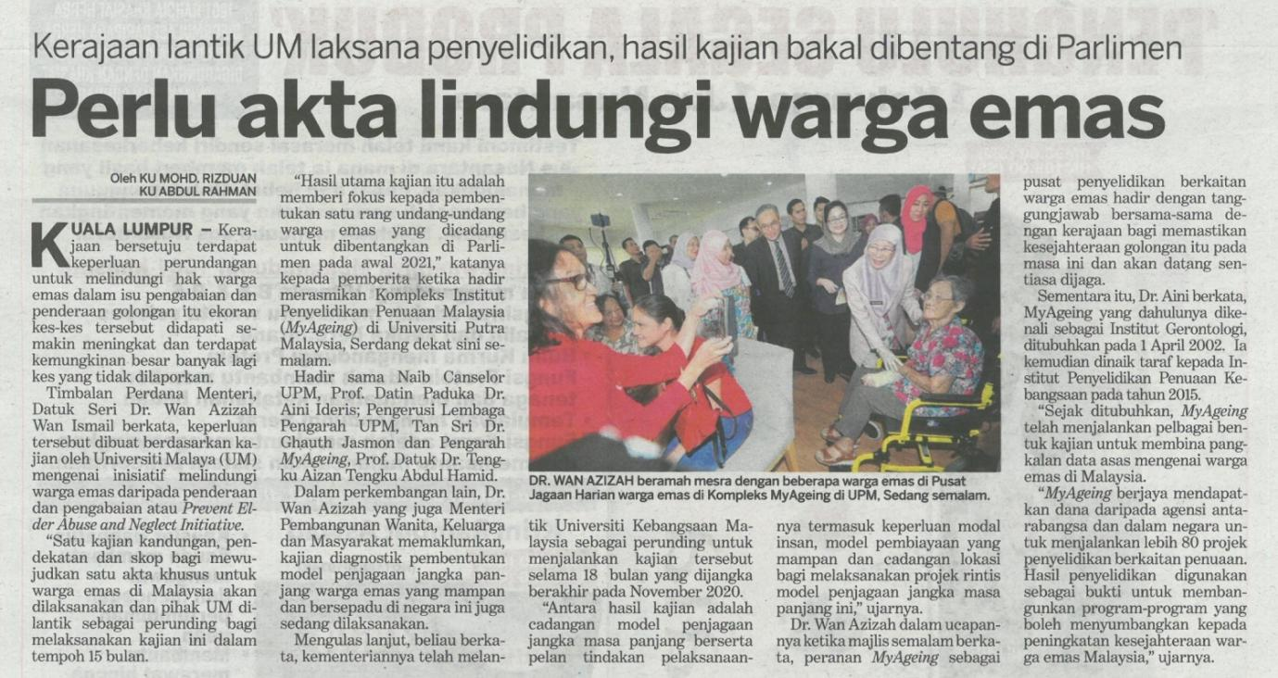

1. **Introduction**
2. **Project overview**

IQ Quest is the name of a project that focuses on sharpening the mind and boosting cognitive abilities through a digital game. It's suitable for everyone but has a special focus on older adults. The game includes various brain activities such as quizzes, puzzles, and problem-solving tasks that are straightforward yet captivating.

The primary aim of IQ Quest is to keep older individuals mentally engaged, reduce mental decline, and encourage ongoing learning in an enjoyable manner. It comes with features like big, clear text, simple navigation options, and both offline and online capabilities so that older users can easily use it even if they have eyesight problems or limited internet access.

This new development holds significant value for the community by not only offering entertainment and engagement but also supporting mental well-being, patience, and social connections among seniors. By turning brain activities into fun challenges, IQ Quest helps older adults remain alert, socially connected, and self-assured in their daily routines.

**b. Background**

In many communities, senior citizens face significant challenges that impact their daily lives and well-being. One major issue is social isolation, as many elderly individuals live alone or have limited interactions with others. They often struggle with limited mobility, preventing them from participating in physical or social activities outside their homes. Additionally, a lack of access to engaging services or suitable activities leaves them with few opportunities to stimulate their minds. This can lead to boredom, loneliness, and in some cases, a decline in cognitive health. These challenges show the need for enjoyable and accessible solutions that seniors can use at home to stay mentally active and socially engaged.

Historically, various efforts have aimed to support senior citizens. For instance, community centers often organized social events, reading programs, or light exercise sessions. Some NGOs and local governments provided printed magazines, puzzles, or workshops to engage the elderly. While digital platforms like quiz or brain training apps exist, many were not created with seniors in mind. Small text, complicated navigation, and reliance on internet connectivity made these tools less effective for older users. These limitations highlighted the need for a more user-friendly and senior-focused solution, leading to the development of IQ Quest, a mental challenge game designed specifically for senior citizens.

**c. Problem Statement**

The main problem that IQ Quest wants to solve is the lack of engaging and suitable mental activities for seniors. Many current brain training games do not meet their needs because they have small fonts, complex interfaces, or need a steady internet connection, making them hard to use. If this issue is not resolved, seniors may face limited mental stimulation, a decrease in cognitive sharpness, and fewer chances for fun challenges. Over time, this can lead to boredom, a loss of confidence, social isolation, and even cognitive decline.

1. **Objectives and Purpose of the Case Study**

**a. Objectives**

The goals of this project are to assess how well IQ Quest engages senior citizens and motivates them to stay mentally active. It also aims to measure elderly users' satisfaction with the game's accessibility, design, and impact on their daily lives. Another key goal is to identify challenges seniors face when using the game and to find ways to improve it so that the app can better serve their needs.

The evaluation will use several criteria, such as the participation rate of senior citizens, their feedback and satisfaction levels, how easy the app is to use, and its overall cost compared to the social and mental health benefits it offers.

**b. Purpose**

The purpose of this case study is to understand how IQ Quest positively affects senior citizens. It focuses on improving their cognitive health, patience, and overall mental sharpness. The study also shows how the game can help lessen feelings of boredom and isolation while providing a fun and interactive way for seniors to challenge and train their minds.

The findings will help community leaders and local governments who want to introduce more digital initiatives for seniors. They will also assist NGOs and health organizations that aim to support mental health for the elderly. Additionally, these insights will benefit developers and innovators looking to create digital solutions designed for senior citizens.

1. **Literature Review**
2. Related Literature

Previous studies have found that brain-training apps and computer games can be significant for the mental health of older persons. Research conducted abroad highlights that older persons who engage in games such as puzzles, quizzes, or memory games are likely to have better cognitive abilities and slower mental decline. For example, studies in the United States and Japan have revealed that simple computer games with larger fonts and easy-to-use interfaces can reduce boredom and enhance the mental well-being of older individuals. Locally, NGOs and community groups have occasionally provided traditional puzzle books, reading circles, or group activities for seniors but have too often been limited in scope and impact by mobility issues and a lack of digital personalization. Best practices from successful programs emphasize the importance of accessibility features such as offline access, intuitive interfaces, and content that is relevant to seniors' interests and skill levels. These principles are a foundation and source of inspiration for the design of IQ Quest, rendering it not only intellectually stimulating but also user-friendly and easy to navigate.

1. **Theories and Concepts**

This game is supported by several theoretical frameworks, among them the Active Aging Theory that concentrates on the necessity of sustained engagement in physical, social, and intellectual activities to lead to health and happiness in the elderly. In providing a game that challenges memory, patience, and problem-solving skills, IQ Quest encourages older people to engage their minds, a sentiment aligned with the active aging philosophy. Besides this, the Social Inclusion Theory highlights the need for interaction and participation opportunities among seniors. Through shared similarities and discussions about the concerns of the game, seniors feel a sense of belonging and togetherness despite being in virtual settings. These theories complementarily highlight the ways in which IQ Quest can meaningfully assist in facilitating mental stimulation, reducing isolation, and improving overall quality of life for older citizens.

1. **Research Methodology**
2. **Research Methods**

IQ Quest research will adopt a mixed qualitative and quantitative approach to gather comprehensive information about the effectiveness of the project. The data will be collected through surveys of elderly people to determine their level of engagement, satisfaction, and perceived benefit after playing the game. In addition, interviews with project managers, community leaders, and caregivers will be conducted to also learn more about the issues of elders and the potential improvements that can be made to the app. Observation of elders as they play the game will also provide valuable information on usability, accessibility, and overall user experience. They were chosen because they offer a balance between measurable outcomes and personal experiences, making them suitable for a project that is equally concerned with cognitive impact and social relevance.

1. **Study Sample**

The study subjects will mostly be elderly persons who are sixty years and above because they are the direct beneficiaries of the IQ Quest project. The caregivers, local stakeholders, and community volunteers will also be included as participants to provide complementary data on how the game influences the daily lives of seniors. Participants will be selected using purposive sampling to ensure that individuals with different levels of digital literacy, health status, and living conditions are included. In this manner, inputs from a variety can be gathered and the inclusivity and flexibility of the game more effectively determined.

1. **Research Instruments**

The primary instruments for data gathering will be standardized questionnaires to quantify user satisfaction, usability, and cognitive stimulation caused by the game. Semi-structured interview guides will also be drawn up to allow space for exploring the seniors' and caregivers' personal experience and feedback. These tools will be developed carefully using plain and clear language, and pilot-tested on a small group of seniors to see if the questions are understandable and relevant. The result of the pilot test will be used to make revisions to the tools, thereby increasing their accuracy and reliability in gathering valid data for the research.

1. **Project Overview**
2. **Project design**
3. **Implementations process**
4. **Risk management plan**
5. **Data Analysis and Findings**
6. **Data Analysis**
7. **Key findings**
8. **Impact on the community**
9. **Public Opinion**
10. **Feedback**
11. **Strengths and Weaknesses**